PRINTABLE SCHOOL LUNCH BOX TAGS

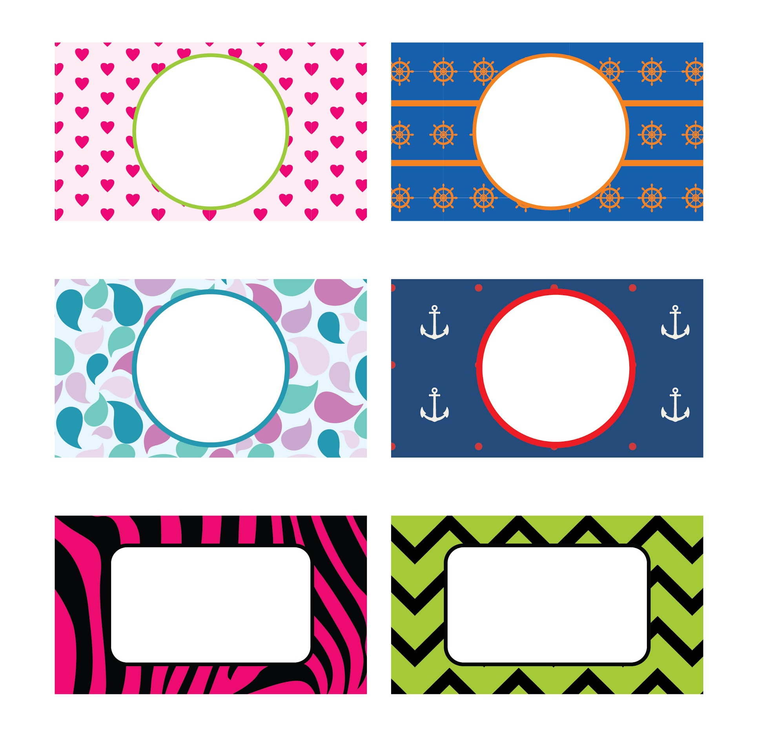

courtesy of Coffee Cups and Crayons I for personal use only

