Brown Bear Puppet Tracing Patterns
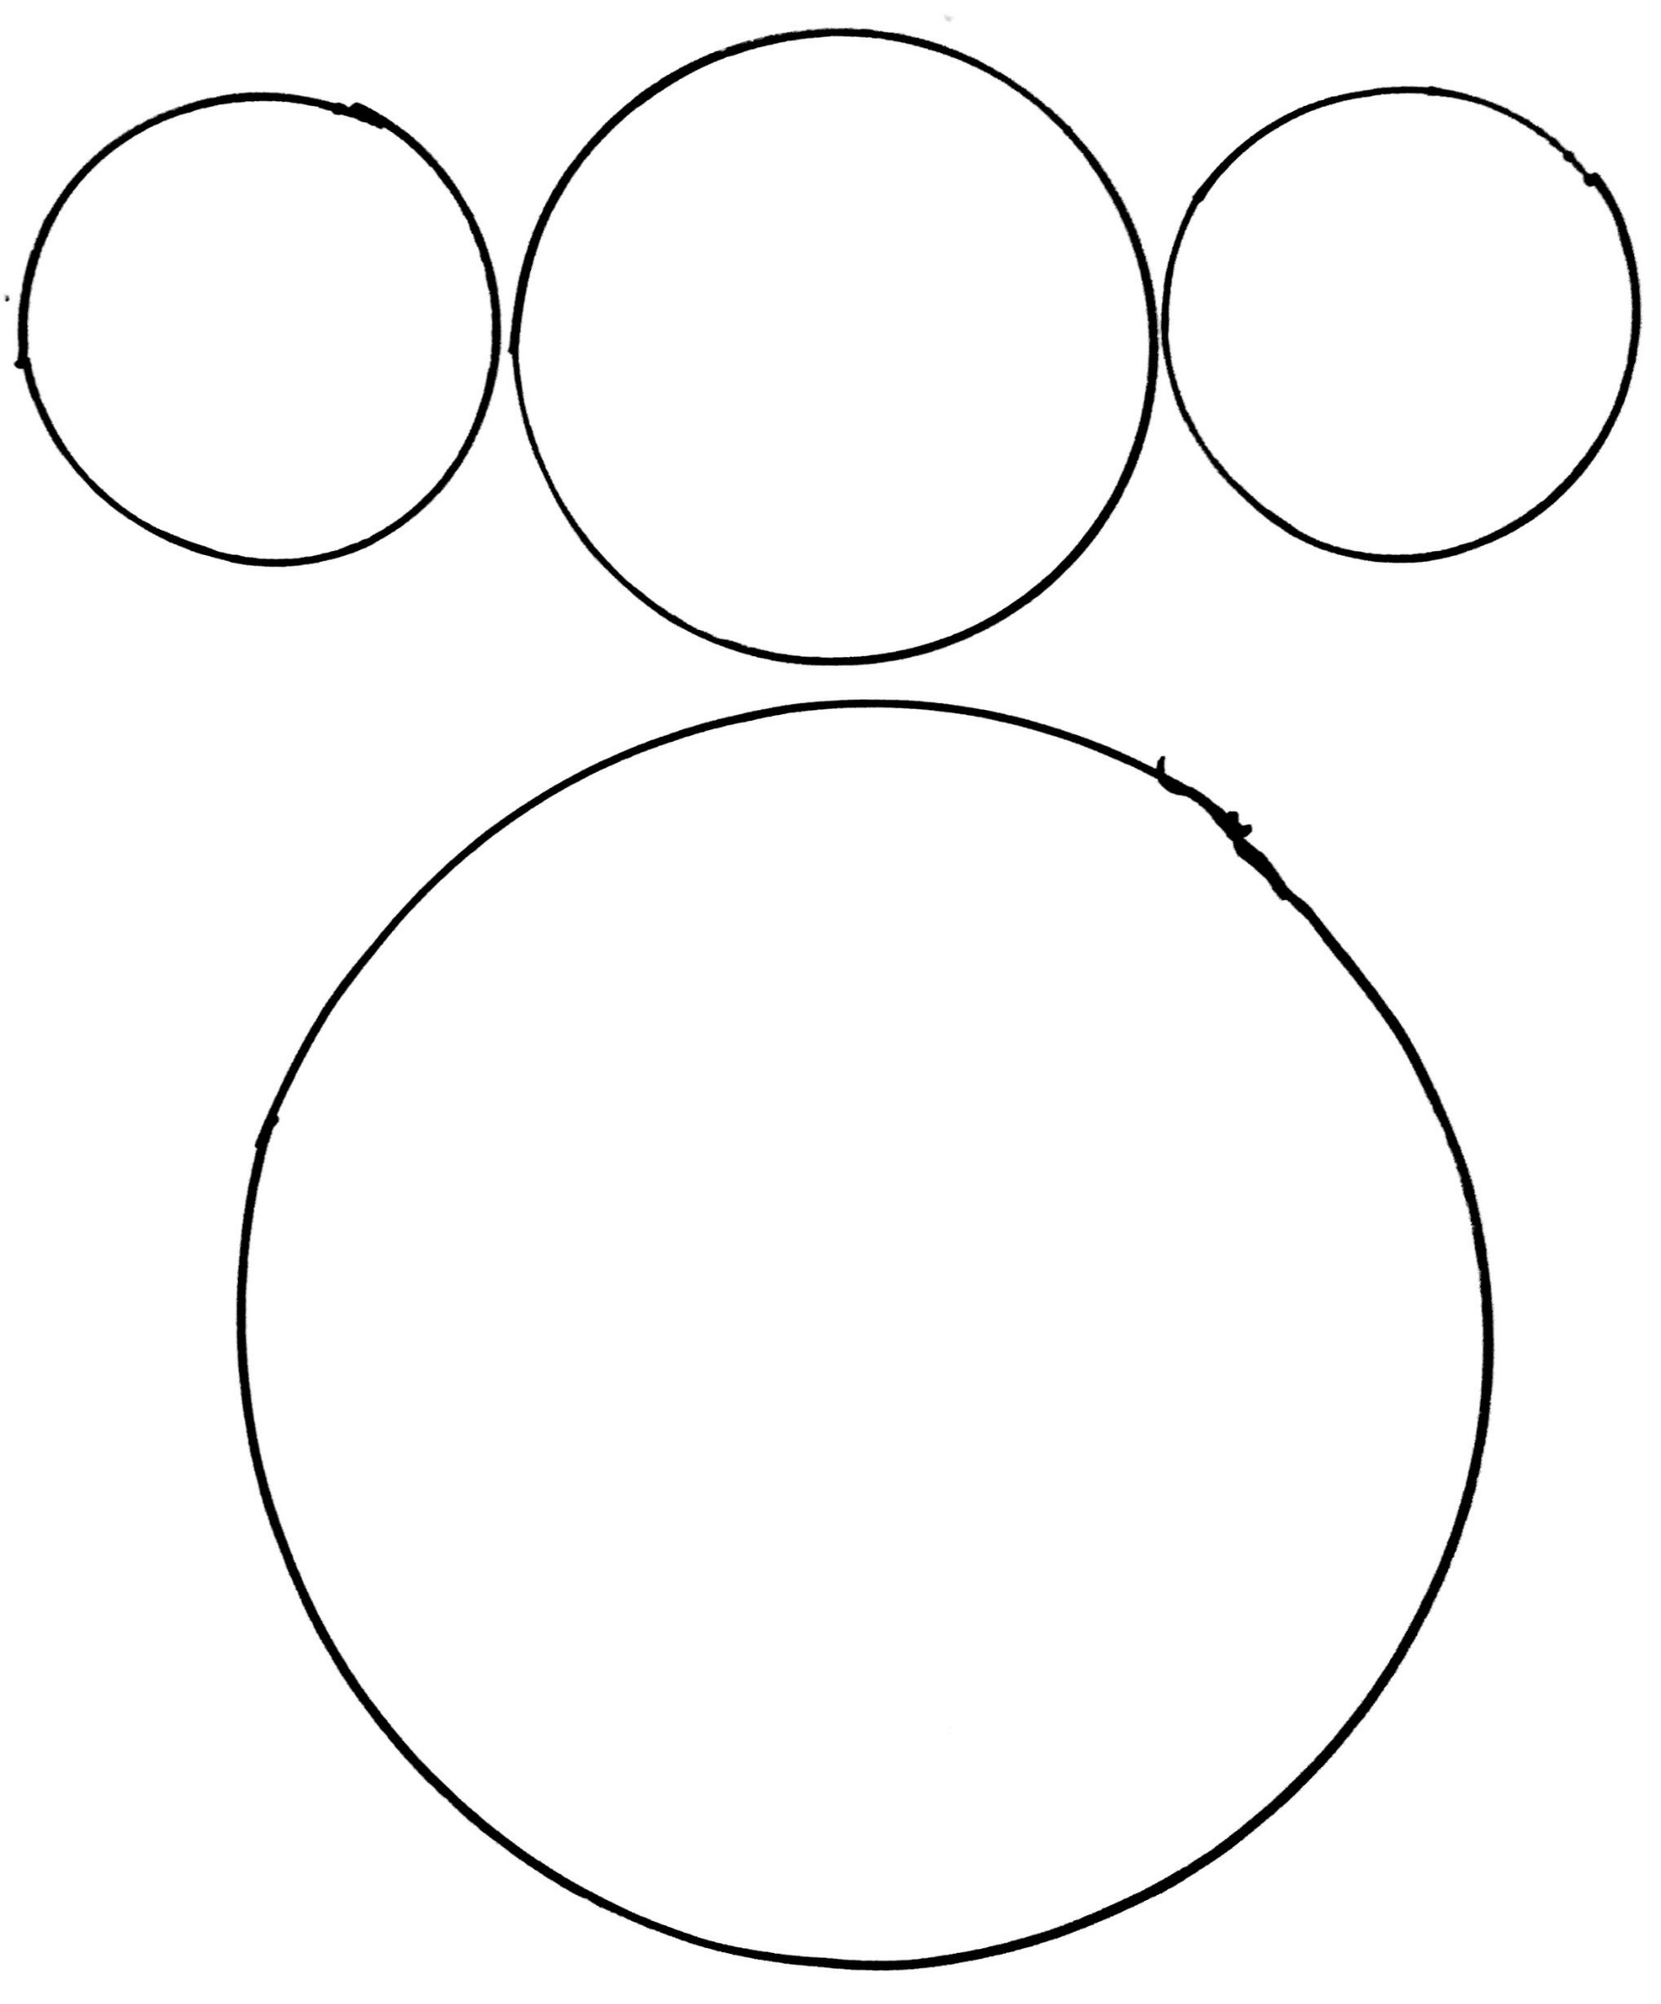
Printable courtesy of Coffee Cups and Crayons for personal and classroom use only.

