KINDNESS JAR PRINTABLE TAGS!
Print and cut out. Punch a hole in the top and tie it to the top of your kindness jar with ribbon. Then spread some smiles around!
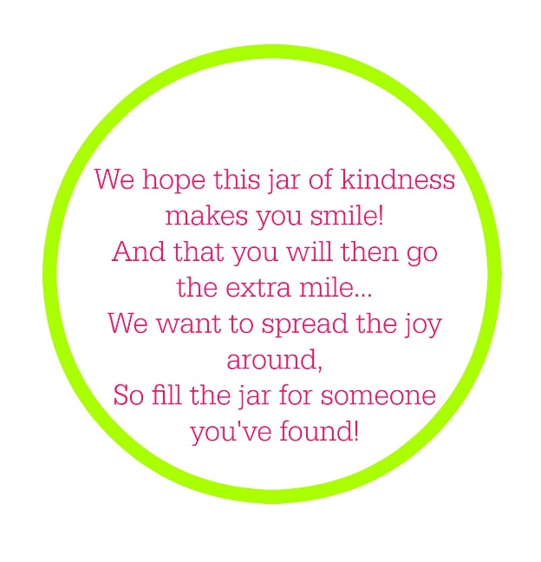

Copyright CoffeeCupsandCrayons.com

